**ACCT / MIS 6309**

**Instructor: Kevin R. Crook**

**Fall 2016**

**Data Visualization Project**

**Last Name: Dhavale**

**First Name: Gaurav**

**Middle Name: Dilip**

**Comet Creed -** *“As a Comet, I pledge honesty, integrity, and service in all that I do.”*

**Electronic Signature:** Gaurav

# Data visualization on Consumer complaints

About dataset:

It’s a database of the Consumer Complaint which contains data from the complaints received by the Consumer Financial Protection Bureau (CFPB) on the various financial products and services. This includes bank accounts, credit cards, credit reporting, debt collection, money transfers, mortgages, student loans, and other types of consumer credit. The database is collected from www.consumerfinance.gov website on 11/21/2016 and it contains over 600,000 anonymized complaints. Data available about each complaint includes the name of the provider, type of complaint, issue, date, zip code, consumer disputed and other information. This dataset is available for public access and use. The CFPB does not verify the accuracy of all facts alleged in the complaints but takes steps to confirm the authenticity of the relationship between company against whom the complaint is filed and consumer.

More information about fields in dataset is as follows:

|  |  |
| --- | --- |
| Date received | The date the CFPB received the complaint. |
| Product | Type of product the consumer identified in the complaint like consumer loan |
| Sub-product | Subproduct of product category like vehicle loan for loan product |
| Issue | Issues faced while using service like incorrect info about loan account |
| Sub-issue | More specific info on issue like incorrect loan amount in loan account |
| Consumer complaint narrative | Detailed information given by consumer on complaint |
| Company public response | Company’s response to consumer complaint |
| Company | Name of company |
| State | Company’s location information |
| ZIP code |
| Tags | Data that supports easier searching and sorting of complaints submitted by or on behalf of consumers. |
| Consumer consent provided? | Whether the consent is provided or not to publish the complaint narrative. |
| Submitted via | How the complaint is registered to CFPB like via web or phone. |
| Date sent to company | Date when the complaint is sent to the company |
| Company response to consumer | Response was given by company on complaints |
| Timely response? | Whether the response is given on timely basis or not |
| Consumer disputed? | Whether the response resolved dispute or not |
| Complaint ID | Unique id assigned to the complaint |

The dataset can help to visualize wide ranges of scenarios such as overall company’s reputation, complaints status, maximum complaints received by which company.

This dataset will help to understand issues faced by the consumer with financial companies. These complaints can be analyzed to understand the trends of complaints. This will further help the government in enforcing federal consumer financial laws for consumer safety and also to supervise financial organization.

Database visualization will also help financial companies to analyze their quality performance and thereby defining improvement strategies. It will also hence consumer the choose the bank based on other consumer experience.

5 specific business questions that can be handled

1. Financial companies with a maximum number of resolved complaints
2. Region wise complaints about different product for “Bank of America”
3. Products for which consumer raised maximum complaints
4. Maximum timely response for current and last year by top 10 companies based on count of complaints
5. Issue reporting modes.

These different questions can be visualize using different tableau designs.

1. Financial companies with a maximum number of resolved complaints

We can visualize this requirement using company and count of consumer disputed filed.

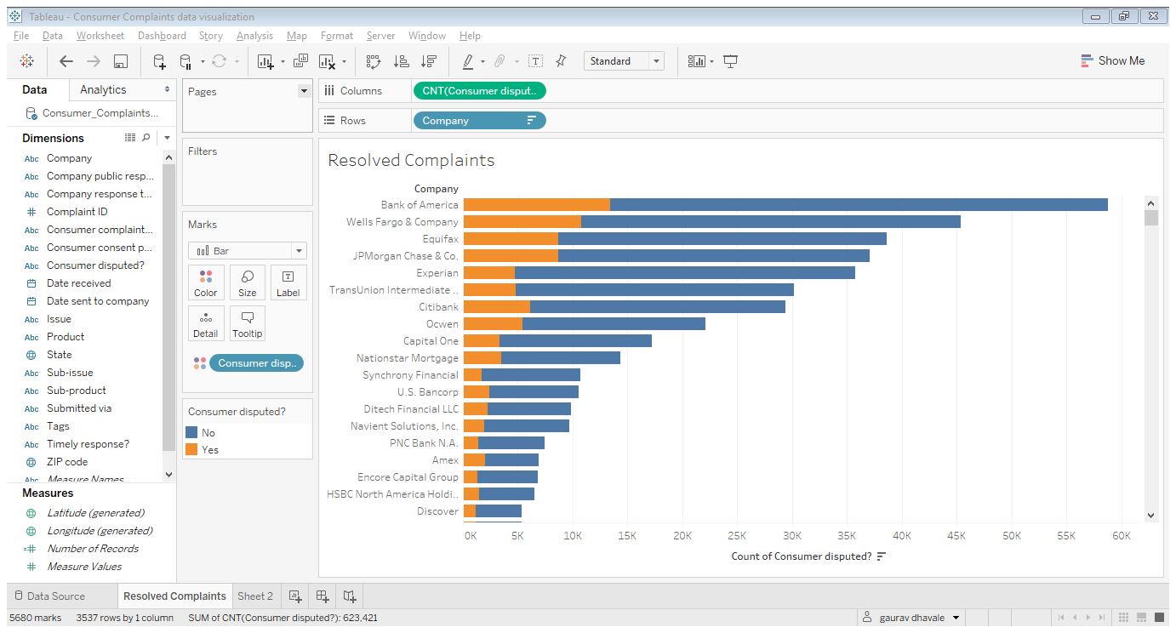

The above image indicates the horizontal bar graph of the company against the count of consumer disputed. In the bar graph, orange color indicates a count of customers whose complaints are resolved and blue color indicate a count of customers whose complaints are not resolved.

From the data, we can see that Bank of America receives maximum complaints (60k) out of which less than 15k are resolved and more than 45k are not resolved.

This information can also be obtained for the current year by adding “date sent to company” field and grouping data based on yearly and filtering it to show only **current year data**.

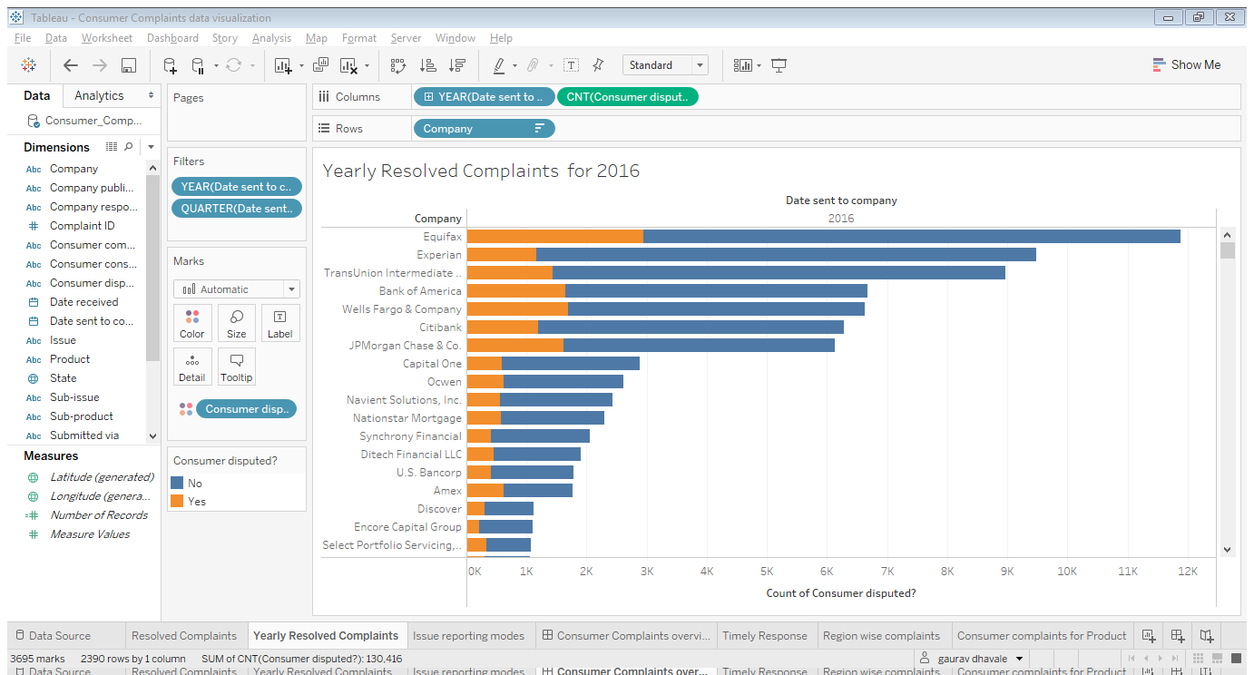

In order to understand which companies has resolved maximum complaints, we need to create a dashboard that will highlight the ranking of companies based on issues they have resolved.

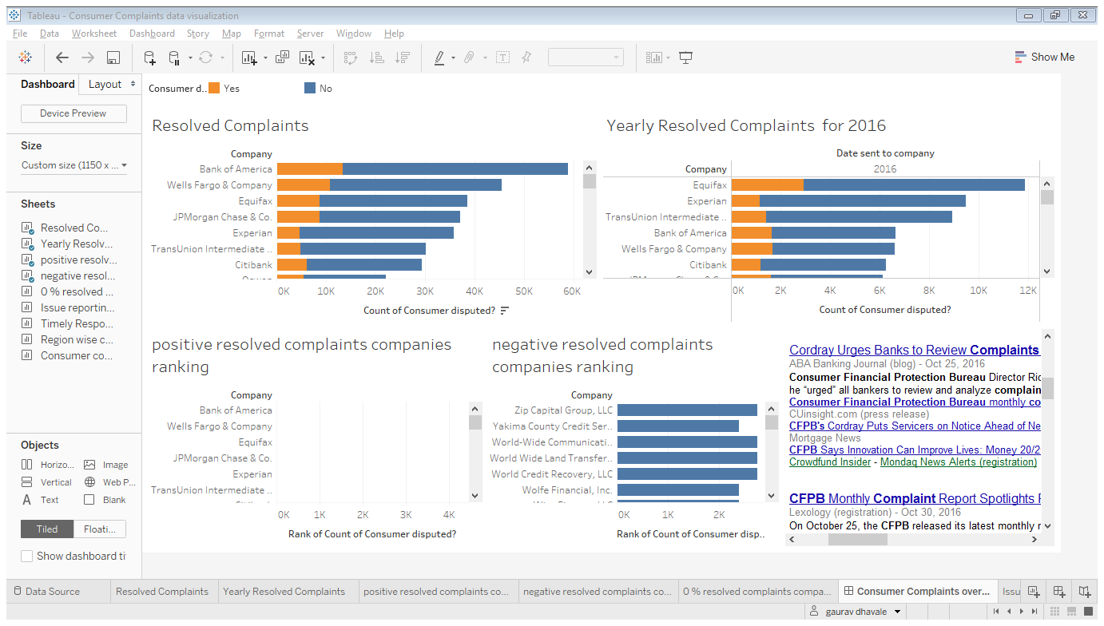

The above dashboard contains 5 different sheets and one external link.

**Resolve Complaints** gives information on financial companies with a number of complaints raised, and out of raised complaints how many are resolved and how many are unresolved.

Yearly resolved complaints highlight information of **Resolve Complaints** sheet but for the year 2016 only.

**positive resolved complaints companies ranking sheet** ranks companies based on a number of complaints they have resolved whereas **negative resolved complaints companies ranking sheet** gives opposite info.

**The web link** is added that points to **google.news.com** which gives updates on consumer complaints dispute.

The dashboard reports can also be filtered for a specific company as well.

We can observe that the below dashboard shows specific info for “Bank of America”.

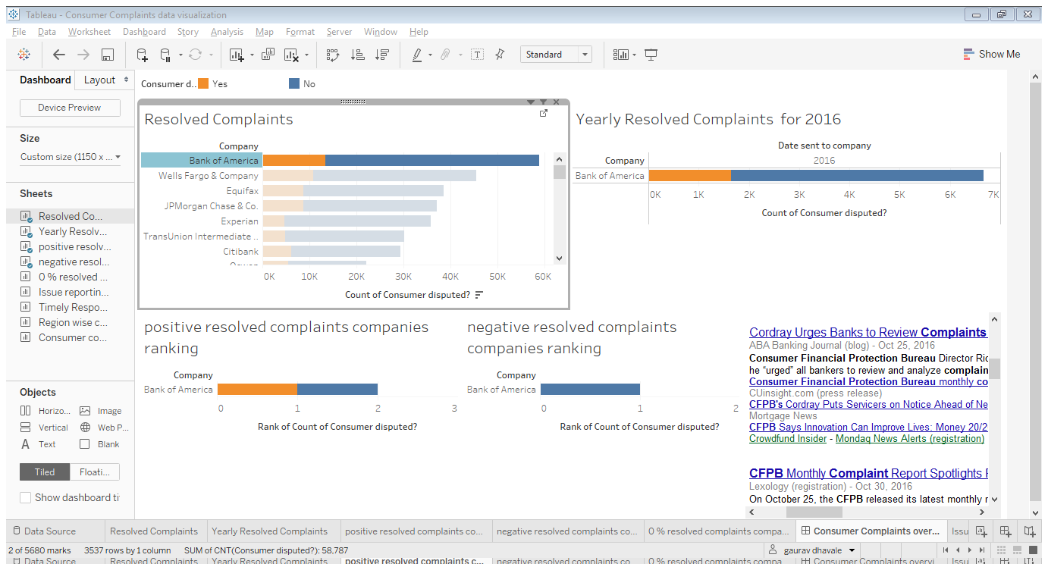

1. Region wise complaints about different product for “Bank of America”

To get this information, we can use state, product, and company dimension. For state dimension, latitude and longitude measures are generated. The company is added in the filter section in order to select “Bank of America” only. The product is added in color marks and state is added in detail marks.

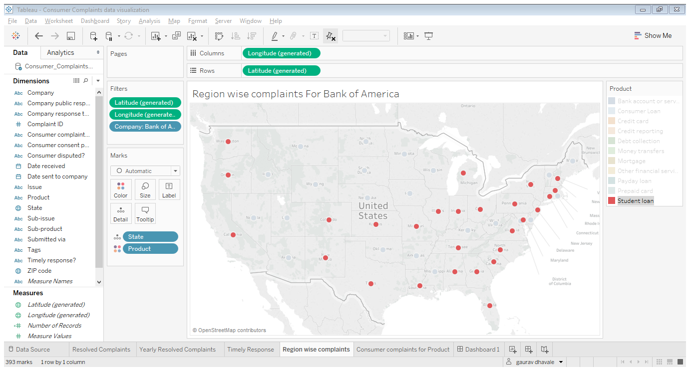

The above indicates issues for a different product in different states for Bank of America. It highlights issues for a student loan in a red color circle in different states.

Similarly, we can generate reports for issues related to other products as well.

Consumer complaints about credit reporting issues are highlighted in orange dots

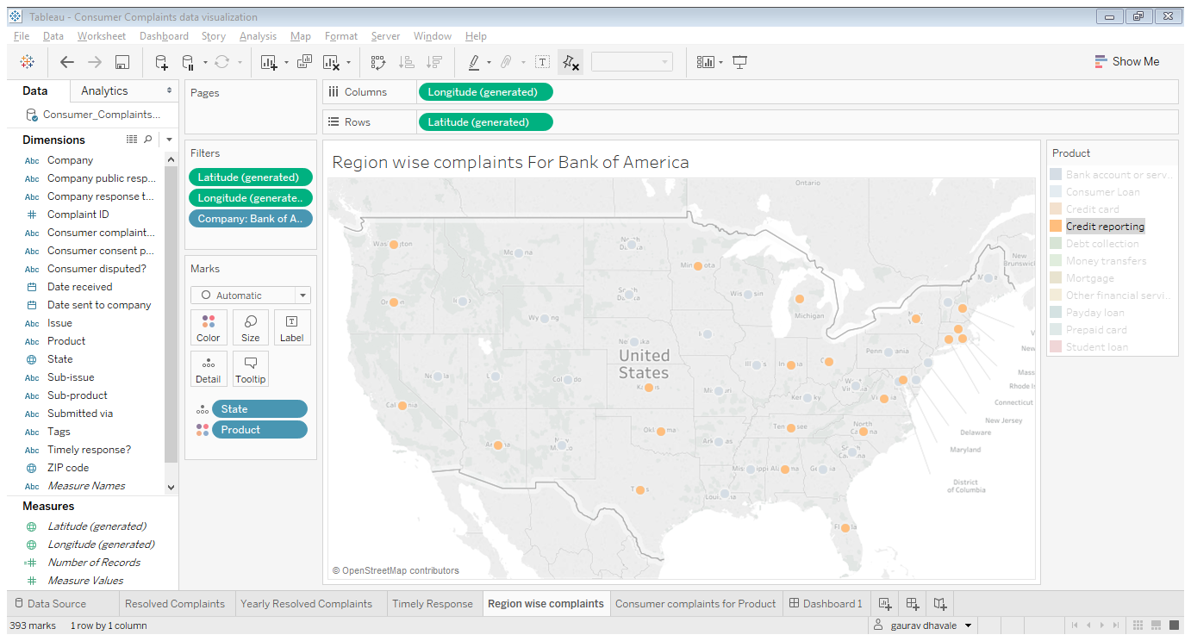

1. Products for which consumer raised maximum complaints

To obtain products for which consumers have raised maximum complaints, we can use complaint id to get all list of complaints against the product.

The below graph indicate maximum complaints were received for mortgage whereas virtual currency has lowest consumer complaints.

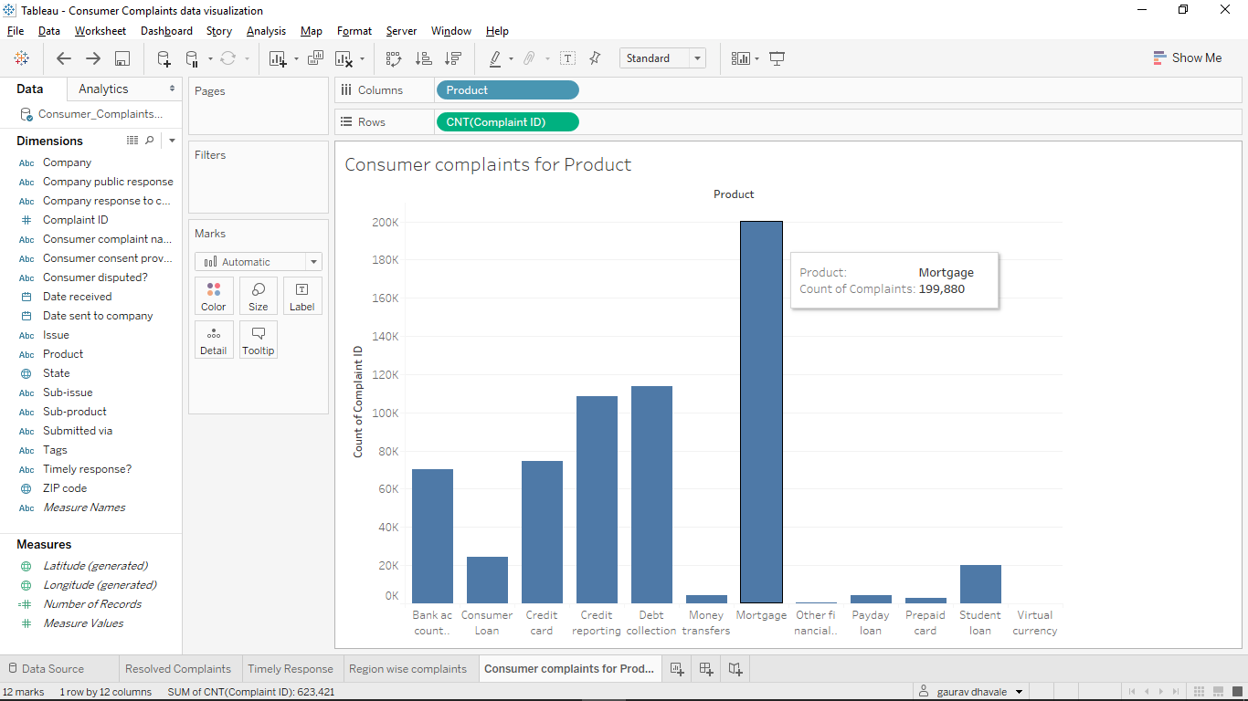

If we add “consumer disputed” field in color marks, we can get how many complaints are resolved out of a number of complaints raised.

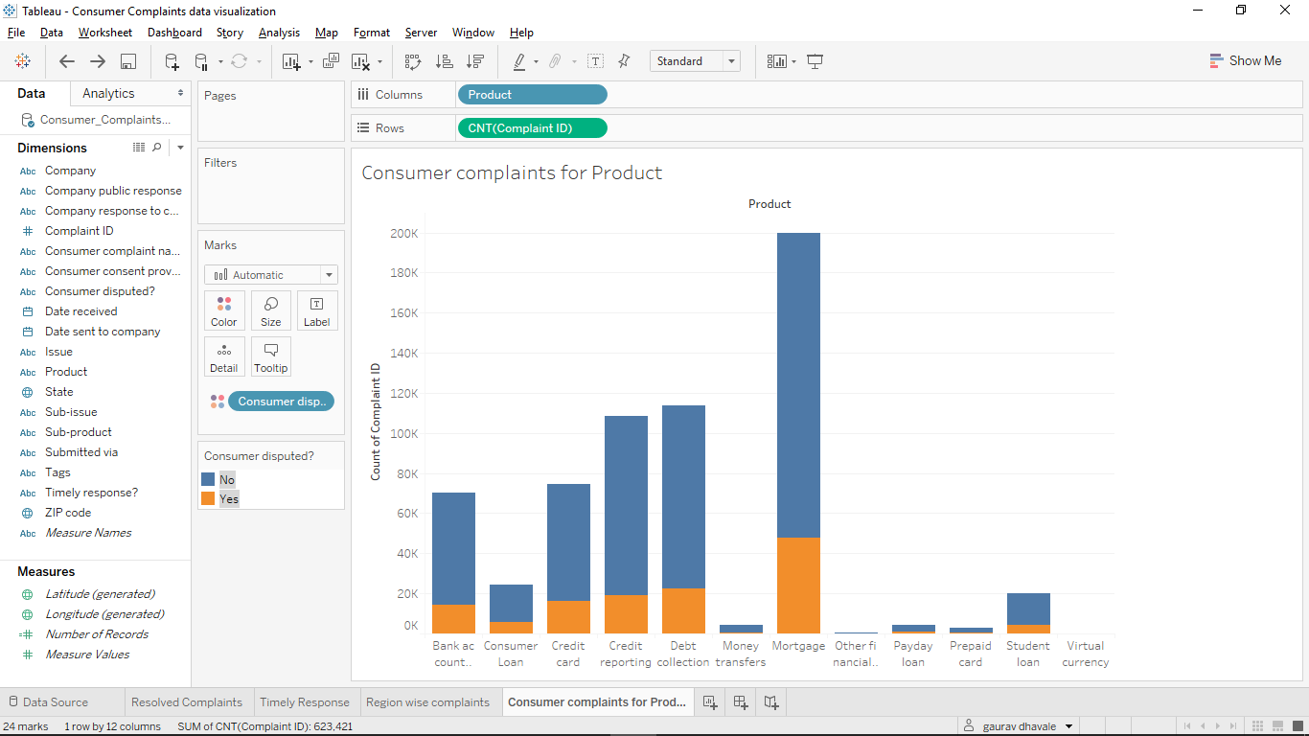

1. Maximum timely response for current and last year by top 10 companies based on count of complaints

The following visualization is obtained by following operations

* + Adding top company filter based on consumer complaints
  + Date received field is shown yearly format by filtering it with current and last year
  + Truly response is added in color marks
  + Count of the complaint is considered using complaint id.

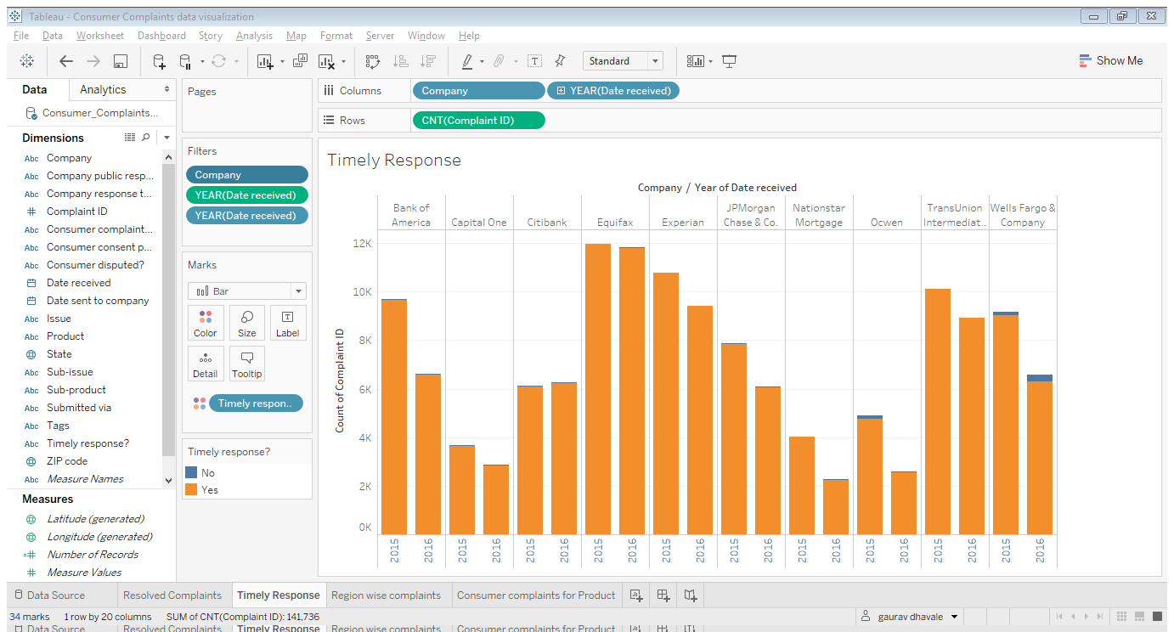

The graph shows that all the companies have responded timely to the complaints raised by the consumer. We can also deduce that the Equifax company has received maximum complaints.

1. Issue reporting modes and overall consumer complaints overview.

Issue reporting modes

Visualization shown below is a “side by side bars” chart highlights different modes used by consumers to report their complaints CFPB. We can observe that the consumer heavily uses web mode to report their complaints. We can also visualize that in many complaints consumer disputed response is No.

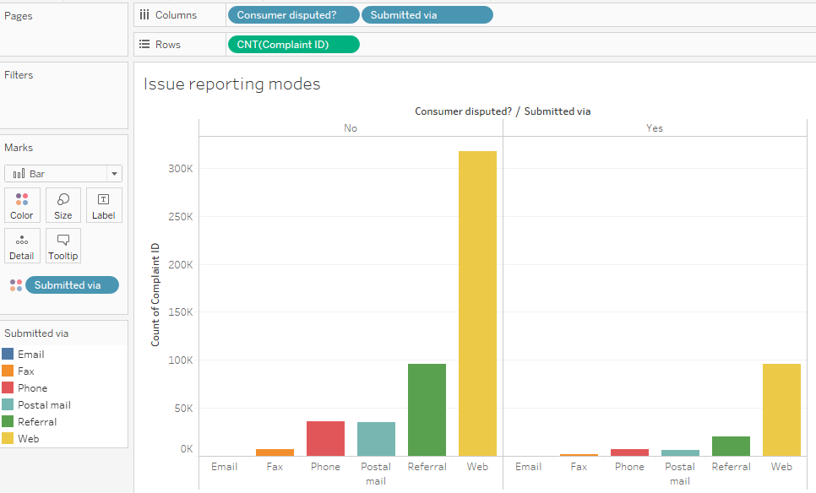

The overall project is clubbed into a story by adding dashboards and sheets.

Tableau Public server link for story is as follows:

https://public.tableau.com/profile/gaurav.dhavale#!/vizhome/ConsumerComplaintsdatavisualization/ConsumerComplaintsVisualization